Учебник Бескоровайная «A Planet of English»:
Бесплатно скачать электронный учебник с грамматикой в удобном формате, смотреть и читать: https://fileskachat.com/file/51179_cc220697e9d2bcb2021f03f5bf8b2979.html

28.11.24г
Группа 1-ОР-22
Преподаватель Панкратова ЮВ
Тема: Известные ученые-геологи и исследователи. А.М. Терпигорев.
А.М. Terpigorev (1873-1959) 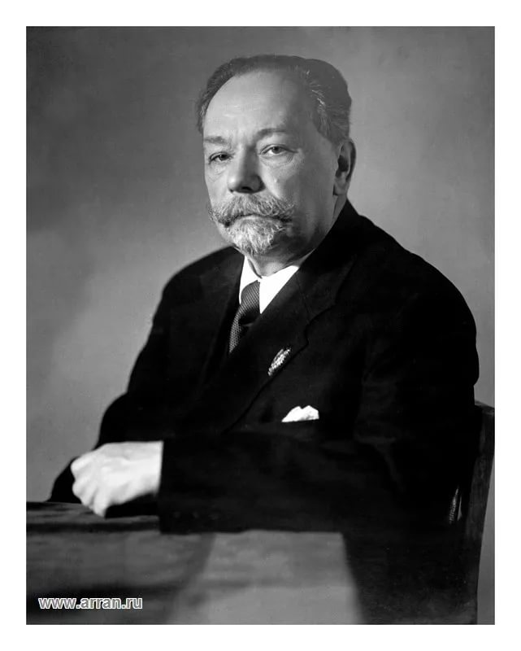
Academician A.M. Terpigorev is a well-known mining engineer who successfully combined his practical experience with scientific research. He was bom in 1873 in Tambov. In 1892 he finished school with honours and decided to get a higher education. He chose the Mining Institute in St. Petersburg, passed all the entrance examinations successfully and became a student of the Mining Institute.
At the Institute he studied the full range of subjects relating to metallurgy, mining and mining mechanics.
At that time students' specialization was based on descriptive courses and elementary practical training. One of the best lecturers was A. P. Karpinsky. His lectures on historical geology were very popular.
During his practical training Terpigorev visited mines and saw that the miners' work was very difficult. While he was working in the Donbas he collected material for his graduation paper which he soon defended. The Mining of flat seams in the Donbas was carefully studied and described in it.
In 1897 Terpigorev graduated from the Institute with a first-class diploma of a mining engineer.
His first job as a mining engineer was at the Sulin mines where he worked for more than three years first as Assistant Manager and later as Manager.
From 1900 till 1922 Terpigorev worked at the Yekaterinoslav Mining Institute (now the Mining Institute in Dnepropetrovsk).
In 1922 he accepted an offer to take charge of the mining chair at the Moscow Mining Academy and moved to Moscow. From 1930 he headed the chairs5 of Mining Transport and Mining of Bedded Deposits at the Moscow Mining Institute.
Academician Terpigorev took a particular interest in mine safety. As a result of his investigations a series of safety measures in gassy collieries was worked out. For some time he was working on the problem of fire damp, the most harmful and dangerous of all the gases in mines.
His two-volume work Coal Mining and Mine Transport Facilities is a full description of the state of mechanization and the economy of the Donbas. His other works are about mining transport facilities, mechanization of coal mining and mining machinery. He is one of the pioneers in scientific methods of coal gasification.

Задание: 1. Прочитать и перевести текст.

2. Выполнить письменно в тетради. Найти эквиваленты слов и словосочетаний в тексте:
1. известный горный инженер
2. практический опыт
3. научное исследование
4. горный институт
5. историческая геология
6. дипломная работа
7. исследования
8. горизонтальные пласты
9. газовые угольные шахты
10. рудничный (гремучий) газ
11. добыча угля и горный транспорт
12. газификация угля

3. Перевод текста выполнить письменно.

4. Иметь задание в наличии в рабочей тетради.
Обратная связь: 9061900457 Telegram (если есть вопросы)
E-mail: grossbach@mail.ru

P.S. если вы забыли, как читается слово, используйте Google-переводчик в своем мобильном, он проговаривает нужное слово.

