Найдите в интернете Учебник Бескоровайная «A Planet of English», формат PDF:
Бесплатно скачать электронный учебник в удобном формате, смотреть и читать:
https://vk.com/wall-45671400_20212 (скопируйте ссылку и вставьте в браузер, увидите учебник в формате PDF; можно листать страницы )

https://fileskachat.com/file/51179_cc220697e9d2bcb2021f03f5bf8b2979.html

Дата: 27.03.25г
группа 1-ОР-24
преподаватель: Панкратова ЮВ
обратная связь: 9061900457 Telegram

Тема: The Political System of Russia. Политическая система в России.

Task: 1. Study the Vocabulary, Ex 7, р 145. Записать слова в тетрадь, повторить устно (проговорить).

Task 2. Ex 8, p 146. Прочитать и перевести текст письменно в тетрадь.

«The Political System of Russia»

The Russian Federation was set up by the Constitution of 1993. After its destruction in 1991, the Soviet Union was broken up into an independent Russian and 14 other new, sovereign nations.

The Russian Federation is a presidential (or a constitution) republic. The President is the head of state and is elected directly by the people. He controls all the three branches of power. The President is commander-in-chief of the armed forces, he makes treaties and enforces law, appoints the prime minister, cabinet members and key judges. The President can override and in some cases even dissolve the national parliament, the bicameral Federal Government. The President is involved in the work of the legislative executive branches.

The government consists of three branches: legislative, execution and judicial. Each of them is checked and balanced by the President. The legislative power is vested in the Federal Assemble. It consists of the Federation Council (upper house) and State Duma (lower house). The members of the State Duma are elected. It is formed of the heads of the regions. Each Chamber is headed by the Chairman. Legislature is initiated in the State Duma, but to become a law a bill must be approved by the lower and upper houses and signed by the President. The executive power belongs to the Government. The judicial branch is represented by the Constitutional Court, the Supreme Court and regional courts.

Task 3. Ex 9, p 147 (in written form). Записать предложения в тетрадь. Верно утверждение или неверно (по тексту).

Отправить задание на электронную почту. Или иметь задание в наличии в рабочей тетради на уроке.
Обратная связь: 9061900457 Telegram (если есть вопросы)
E-mail: grossbach@mail.ru отправлять задание!

P.S. если вы забыли, как читается слово, используйте Google-переводчик в своем мобильном, он проговаривает нужное слово.

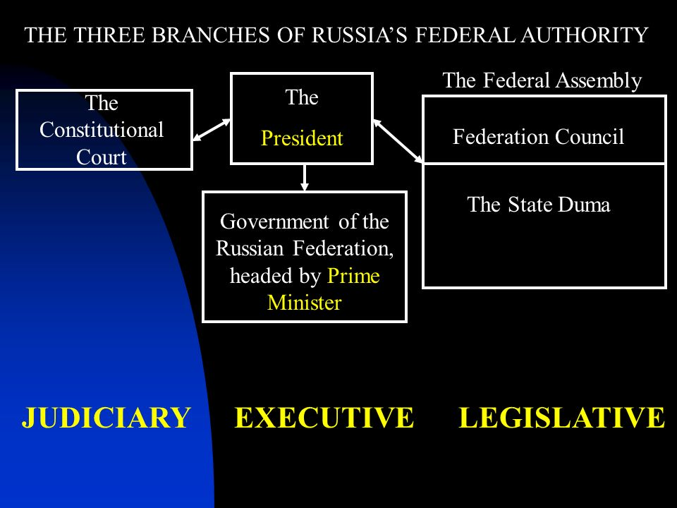

https://vk.com/wall-45671400_20212

