12.09.25г пятница
группа 1-ОР-25 подгруппа 2
Преподаватель: Панкратова ЮВ

Найдите в интернете Учебник Бескоровайная «A Planet of English», формат PDF:
Бесплатно скачать электронный учебник в удобном формате, смотреть и читать:
https://vk.com/wall-45671400_20212

https://fileskachat.com/file/51179_cc220697e9d2bcb2021f03f5bf8b2979.html

Тема: Семья. Сообщение о себе и своей семье.

Задание: 1. Лексика по теме «Семья». Повторить устно (проговорить), выучить наизусть и записать в тетрадь. Упр.1, стр.12.

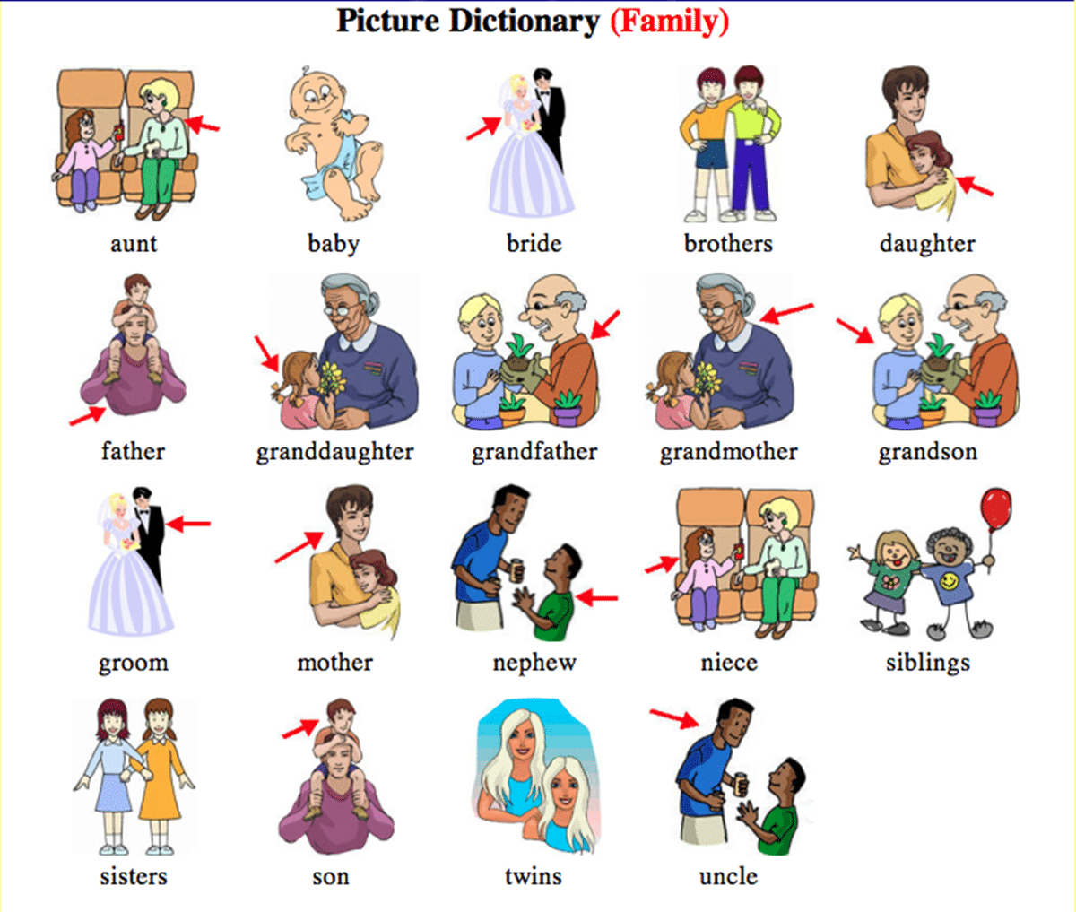

2. Повторить сообщение по плану «About myself and my family».

My name is …, my surname is … .

I’m from …

I live in …

My address is … (street, house, flat)

I’m … years old.

I’m married. (I’m not married).

There are … members in my family.

They are … (mother, father, sister, brother, wife, son, daughter …).

I have a sister/ brother.

She is … years old, her name is… .

He is … years old, his name is… .

My mother is … years old, her name is… .

My father is … years old, his name is… .
I have a hobby. My hobby is …
I have domestic animal(s). I have a cat (a dog, a bird, fish) at home.
Now I’m a student.
I study at the Chernogorsk mining and construction technical school.
I like to study at the technical school.

3. Выполнить письменно:
Упражнение 1
Вставьте глагол to be в Present Simple.
1. What ... your name? - My name ... Shirley Frank. 2. What ... your address? - My address ... 175 Grand Central Parkway. 3. What ... your phone number? - My phone number ... 718-1930. 4. Where ... you from? - I ... from New York. 5. I ... a pupil. 6. My father ... not a teacher, he ... a scientist. 7. ... your aunt a doctor? - Yes, she ... . 8. ... they at home? - No, they ... not at home, they ... at work. 9. My brother ... a worker. He ... at work. 10. ... you an engineer? - Yes, I ... .11. ... your sister a typist? - No, she ... not a typist, she ... a student. 12. ... your brother at school? - Yes, he ... . 13. ... your sister at school? - No, she ... not at school. 14. My sister ... at home. 15. ... this your watch? - Yes, it ... . 16. She ... an actress. 17. This ... my bag. 18. My uncle ... an office worker. 19. He ... at work. 20. Helen ... a painter. She has some fine pictures. They ... on the walls. She has much paper. It ... on the shelf. The shelf ... brown. It ... on the wall. Helen has a brother. He ... a student. He has a family. His family ... not in St. Petersburg, it ... in Moscow.

Упражнение 2
Раскройте скобки, употребляя глаголы в Present Simple.
1. My working day (to begin) at seven o'clock. I (to get) up, (to switch) on the radio and (to do) my morning exercises. It (to take) me fifteen minutes. At half past seven we (to have) breakfast. My father and I (to leave) home at eight o'clock. He (to take) a bus to his factory. My mother (to be) a doctor, she (to leave) home at nine o'clock. In the evening we (to gather) in the living room. We (to watch) TV and (to talk).
2. My sister (to get) up at eight o’clock. 3. She (to be) a schoolgirl. She (to go) to school in the afternoon. 4. Jane (to be) fond of sports. She (to do) her morning exercises every day. 5. For breakfast she (to have) two eggs, a sandwich and a cup of tea. 6. After breakfast she (to go) to school. 7. It (to take) him two hours to do his homework. 8. She (to speak) French well.

4. Иметь задание в наличии в рабочей тетради на уроке.

Обратная связь: 9061900457 Max (если есть вопросы)
E-mail: grossbach@mail.ru
P.S. если вы забыли, как читается слово, используйте Google-переводчик в своем мобильном, он проговаривает нужное слово.

