Преподаватель: Ишимова Н.В.
Предмет: Английский язык
Урок: № 3-4
Обратная связь: e-mail: ishimova80@bk.ru
Группа: 3-ГЭМ-20
Дата: 09.09.2023 г.
Тема: «Мой техникум и моя будущая профессия».
Основные источники:
1. Агабекян И.П. Английский язык для средних специальных заведений: учебник для сред. проф.образования. – Ростов-на-Дону, Феникс, 2010.
https://college-balabanovo.ru/Student/Bibl/Pravo/AgabekEnglish.pdf
Дополнительные источники:
1. Англо-русский и русско-английский словарь. Мюллер В.К., М.: «Эксмо», 2008.
2. Голубев А.П., Балюк Н.В., Смирнова И.Б. Английский язык: учебное пособие для студентов СПО. – М.: издательский центр «Академия», 2006.
3. Интернет-ресурсы:
https://www.study.ru; www.learn-english.ru
Задания:
1. Look at the picture. Answer the question:
What is the job interview associated with?
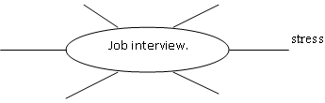
2. Read and translate the text.
«Job interview»

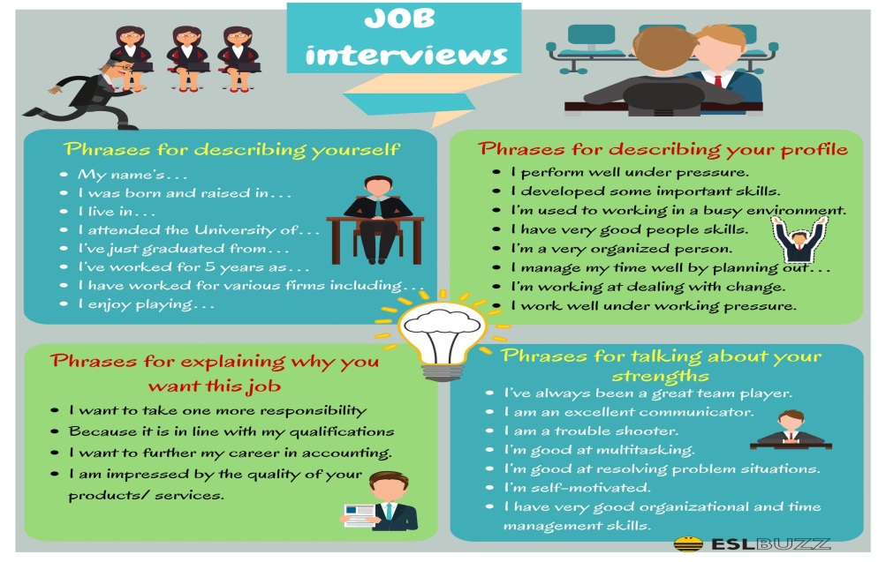
One of the most critical moments in anyone’s career is when they have to face a job interview. It can be especially challenging if you have a job interview in English and you haven’t practiced English so much lately.
Yet, there’s no reason to be nervous. The key to succeed in a job interview in English is the same one you should have in mind when you have a job interview in your mother tongue: you have to come prepared and trust yourself. Otherwise, the interviewers will notice your lack of confidence and you’ll look unprofessional.
But don’t worry! There are always a couple of things you can do if you want to be prepared for every question and scenario your interviewers bring to the table. Today we’re going to take a look at some of the most useful sentences you should keep in mind for your interview in English!

Key Sentences to Introduce Yourself at a Job Interview in English
First impressions are always very important, and for a job interview it’s no different! These are different sentences you can use to
1. Good morning/afternoon. My name is ______ and I want to thank you for this opportunity.
2. Hello! My name is _______ and it’s a pleasure for me to be here.
3. Good morning/afternoon. I’m _______ and I want to thank you for taking me into consideration for this position.
4. Hello! My name is _______ and I’m glad you called me because I really want to work for this company.
5. Hi! My name is ________ and I’m here because I think I have the profile you’re looking for.
6. Hello! My name is _______ and first of all I want to congratulate you for making this company capable of offering a top quality service!
If you want to say something positive about the company or about the position you’ve applied for then this is the perfect time.

Asking Someone to Repeat a Question
One of the most disturbing moments you can go through is if you didn’t understand a question. Don’t feel bad, it’s natural and legitimate to ask for a question to be repeated.
If you didn’t get the question at first, you shouldn’t be afraid to use one of these sentences for a job interview in English to ask someone to repeat it:
7. I’m sorry. Would you please repeat the question?
8. Excuse me, I didn’t hear you. Can you please say that again?
9. Would you please say that again?
10. Could you please repeat the question and speak a little bit harder?
11. Sorry, I didn’t understand you. Could you please say that again?
12. I’m sorry, I didn’t hear the last part. Can you repeat it, please?
Any of these sentences will help you get back on track and continue with the interview while displaying great communication skills and formality.

Emphasizing Your Strengths
Sometimes you may want to highlight some of the features you think make you perfect for the position you’re being interviewed for. Use these sentences for a job interview in English when you want to put emphasis on one of your strengths:
13. I think I’m the right choice for this job because I know how to…
14. My (mention a set of skills relevant for the job) will allow me to do this easily.
15. I’m very good at ________ and that’s why I think I’ll be able to handle this position. (Fill the blank space with the one you consider is your best strength.)
16. I’d love to work here because I _______.
17. I think my ________, my _________ and my __________ make me perfect for this job.
18. I can say my top 3 skills are: ________, _________ and _________.
Try to mention more than one strength you find relevant for the position you applied to. You should also always justify your strengths with an example from your professional experience to show that your strengths are real.

Thanking the Interviewer at the End of the Interview in English
You have to finish your interview as neat as you started it. Don’t let the interviewer/s leave with a bittersweet taste and thank them before the interview is over. These are some sentences for job interviews in English that can help you thanking them:
19. Thank you very much for your time. I’ll be waiting for your call!
20. I want you to know that I’m very thankful for this.
21. Before I leave I want to thank you for the opportunity. I hope we see each other again soon!
22. I wanted to thank you before I leave. I hope I have the profile you’re looking for.
23. It was a pleasure meeting you and then again I want to thank you for having me here!
24. I want to thank you one last time and I’ll be expecting your call!
Using these sentences you will end up the interview in a high and leave an excellent and professional memory in your interviewer’s mind.
Some other sentences for a job interview in English you can find useful are:
25. I’ve been looking for this position for a long time.
26. I love the idea of working here because I enjoy _______.
27. This is what I always wanted to do and I know I can do it very well.
28. I’m glad I was recommended by _______ for this position!
29. I’m glad I saw this job post because I’m very excited about the idea of working for this company.
30. You can expect nothing but proficiency and excellent results if you hire me.
Practice these sentences for your next job interview in English and you’ll be able to walk out of the building knowing you did well.
3. Give an «Advice to an applicant»
- Make a list of questions what you will ask your future employer when applying for a job (at a job interview)
- Make a pyramid of advice on how to behave at a job interview to create a positive impression on the employer.
4. Answer the following questions.
1. Are you good at computer?
2. Can you type fast?
3. Is it possible for you to work on Sundays?
4. What position in our company do you exactly want to get?
5. What salary would you want to get?
6. What is your hobby?
7. Can you work early in the morning?
8. What salary would you want to get?
5. Assess our interview. Give adjectives, describing it.
J- joyful
O- objective
B- beaming
I-
N-
T-
E-
R-
V-
I-
E-
W-

