Преподаватель: Ишимова Н.В.
Предмет: Английский язык
Обратная связь: e-mail: ishimova80@bk.ru
Группа: 3-ТАКХС-21
Дата: 16.02.2024 г.
Тема: «Подготовка рабочего места к работе».
Основные источники:
1. Англо-русский и русско-английский словарь. Мюллер В.К., М.: «Эксмо», 2008.
2. Голубев А.П., Балюк Н.В., Смирнова И.Б. Английский язык: учебное пособие для студентов СПО. – М.: издательский центр «Академия», 2006.
3. Интернет-ресурсы:
https://www.study.ru; www.learn-english.ru
Выполнение заданий:
1. Learn the vocabulary, using the picture below. Rewrite new words into your copybooks and transcribe them.
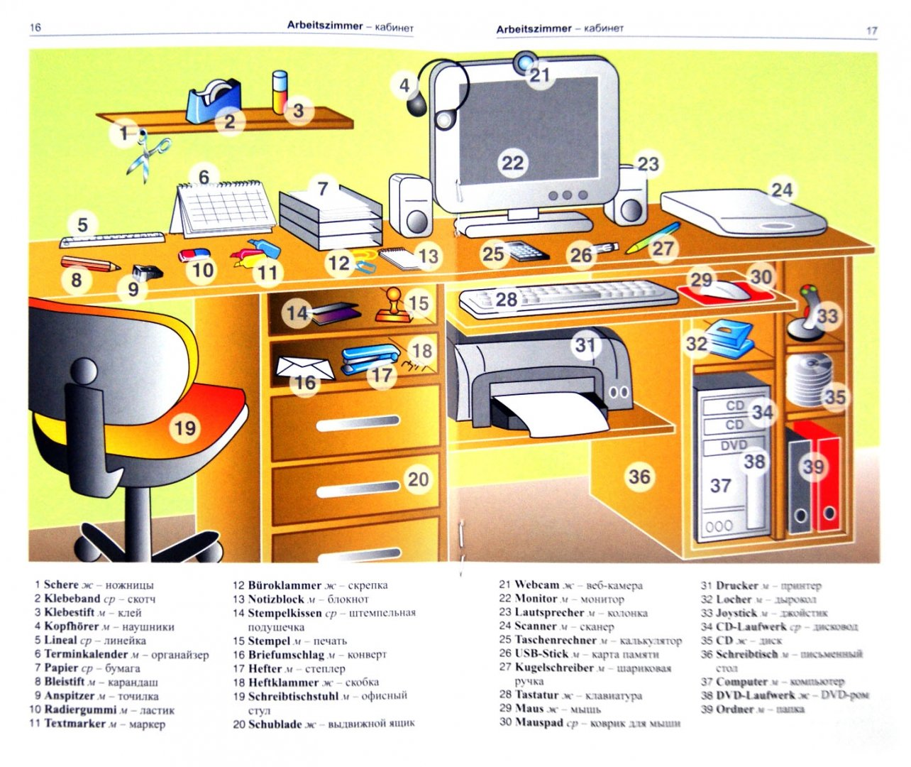

2. Read and translate the text. Answer the question «What is the main idea of the text».

How to Be Organized At Work, School and Home
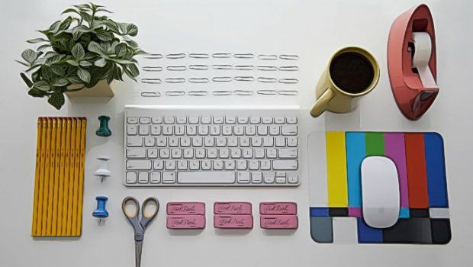
Getting your life in order is a key step toward reaching your success. In fact, there is no secret here. It is a rare person among us who does not feel the demand to get organized. Want to learn how to be organized at work, school and home?
1. Write things down
Could not find your keys procrastinate before an important test or project – these are classic time wasters that keep us from finishing what needs to be done and they happen to most people from time to time. We all know someone who remembers every birthday and sends cards for every holiday. Actually, it is not magic and they do not have to remember all of the events. Trying to memorize things will not help you stay organized. The advice is to write things down. Just a pen and papers are good tools for you to remember all things externally. It is more permanent. You could also use your smartphone or computer to do that job. If you try to remember all important dates and reminders with your head, then you are making your life complicated. It is better for you to write down everything from shopping lists, holiday gifts, important dates, and home décor.
2. Make schedules and deadlines
The next tip on how to be organized at work, school and home is to create a well-planned schedule. In reality, organized people do not waste time. They obviously recognize that keeping things organized goes hand-in-hand with staying productive. Thus, they keep schedules for both the day and week. Also, they make set goals and make deadlines. Most importantly, they stick to those deadlines strictly. By living such a cluttered lifestyle, you will not have the space or time to make the deadlines or gain goals.
3. Stop procrastinating
Did you notice that the longer you wait to do something, the harder it could be to get it done? In order to live a less demanding and less stressful life, you need to stop procrastinating. Getting things done as fast as you could will allow you to lift the weight off you from doing it later.
4. Get things their own home
Things will be easy to get lost if they do not have their own home. Start keeping your life organized by keeping everything in their appropriate places. Organized individuals keep order by labeling different storage spaces.
You should put the things which you often use at easy-to-access places and do not let those storage spaces get clutter. In addition, you should be creative about choosing the proper places for things. Additionally, never label a certain storage space as “miscellaneous!”
5. Avoid bargains and just keep what you really need
You need to get rid of what you do not need. When shopping, instead of bargaining without prior planning, you had better write down precisely what you need and purchase just what you planned. Organized people will not be attracted by false advertising.
Have you ever felt like you not have the space to keep everything you own? Rather than purchasing a larger house or renting storage, you should get rid of some things. If you keep more stuff, it means that you are keeping more clutter. Those people who live organized life just keep what they really need and want. If you have fewer things, it means that you will be able to enjoy them more.
It is all about courage when throwing away something. You will not miss it if it is gone. Instead of throwing away those unnecessary things, you should donate them. That way, you will not only get your home organized but also help other people who really need your thrown-away stuff.
6. Use containers, bins, and separators
For instance, if your garage consists of things you need to keep but do not use often, make use of a container for those things. That way, you will know where to get a specific stuff if necessary. The see-through containers are really useful, yet labeling bins and containers could be also effective. Separating the small items like tools, utensils, or office supplies is useful too.
7. Declutter regularly
It is better for you to set specific time each week to declutter. People who are highly organized make sure they find proper time every week, or more, to organize their home as well as their work. We all know that stuff does not stay organized on its own. In fact, it needs to be well reorganized consistently.
8. Keep your to-do list brief
In order to help you organize your schedule effectively, create a to-do list, but keep it brief. Use bold, big letters and make a list of no more than 5 tasks on the index card. If you want to add any extra items, write them down on the back of the card. If you have done five things, refer to the additional things on the back of the card to create a new to-do list. Remember to discard those old ones. By that way, you will finish more, get less frustrated and manage time better.
9. Start your day right away
When waking up, you should eat a healthy breakfast, wash your face, get dressed, and put on the shoes. Do everything you would do as if you are going to school or work at the office. If so, you will change your mental perspective. By getting ready and making yourself presentable to the world, you are preparing yourself for success.
10. Not overwhelm yourself
In case you find that your schedule is full and your own time is short, consider dropping those less important things from your daily plans. Avoid doing all things at once because that just makes you anxiety-prone and feel unorganized. Cancel plans if necessary to give your mind more thinking space.
11. Learn to delegate responsibilities
The next technique on how to be organized at home or at work is delegation. A really organized life is not overfilled with meetings, responsibilities, and deadlines. If you know you have to go shopping but are too busy to consider the task, you should ask your friends or family members to run the errand for you. Avoid agreeing which you could not complete and do not have time to accomplish. Your friends will not hate you and the boss will not think you slack. Other people will understand if you really need your free time to get your personal work and organization done. When you are not able to do all things with your own, then delegating could be healthy.
12. Do not be a perfectionist
When it comes to how to get organized at work, avoid becoming a perfectionist is a must. You need to stop being a perfectionist, because you are overwhelming yourself. Sometimes, people wait to start till they are in the perfect decluttering mindset; they might be waiting a long time. Once again, avoid procrastination and do not put off projects any longer. If you could reach to the point which is good enough, you will not only move to the next point quickly but also help your mind relieve stress effectively.
13. Put things back instantly
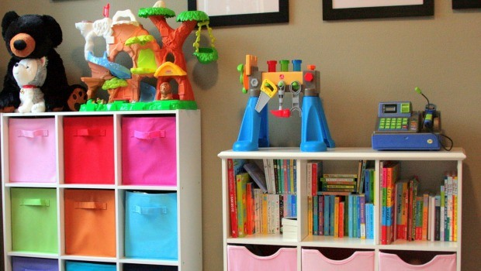
When taking out your pen from the drawer, after writing a note, instead of placing things where it is most convenient, you had better take an additional moment to put it back to its correct place.
If the duty that you are currently considering takes just less than 2 minutes, do it instantly. Getting something done right away will leave your own home organized and you do not have to do it later. In case there are some things lying around in just one area, just take some minutes to put all of them back to their home. This will help you keep clutter from growing larger or harder to handle with.
14. Avoid being a “Weekend Warrior”
One TV, we usually see people devoting their entire weekend to arranging their room or years’ worth clutter. However, it is not good way for you to learn how to be organized. The problem here is that this will rapidly become overwhelming and exhausting.
If you do not accomplish your organizing task, you will feel like you have wasted your entire weekend and the last thing you would do is to begin cleaning again. Rather than, you had better set up one or two specific days in a week for organizing.
Though becoming organized for some people could be a lifestyle change. It actually requires commitment and patience, so do not get frustrated. These «14 tips on how to be organized at work, school and home» article hopefully has helped you get some real steps to become a more organized person.
3. Make up 6 different types of questions according to the text.
4. Home task. Make up a story about your workplace at home, using the picture below.
