**Преподаватель:** Ишимова Н.В.

**Предмет:** Английский язык

**Обратная связь:** e-mail: <ishimova80@bk.ru>

**Группа:** № 3-МД-24

**Дата:** 23.11.2024 г.

**Тема занятия:** «How can I get there? Ориентирование на улице».  
**Основные источники:**1. Безкоровайная Г. Т., Койранская Е. А., Соколова Н. И., Лаврик Г. В. Planet of English: учебник английского языка для учреждений СПО. — М., 2014.

[**https://s.11klasov.ru/12889-planet-of-english-uchebnik-anglijskogo-jazyka-bezkorovajnaja-gt-i-dr.html**](https://s.11klasov.ru/12889-planet-of-english-uchebnik-anglijskogo-jazyka-bezkorovajnaja-gt-i-dr.html)

**Дополнительные источники:**

1. Англо-русский и русско-английский словарь. Карантиров С.И., «Дом славянской книги», 2011.  
2. Интернет-ресурсы:  
<https://www.study.ru>; [www.learn-english.ru](https://ped-kopilka.ru/go/url=http:/www.learn-english.ru)  
**Выполнение заданий:**

**1. Watch the video tutorial by clicking on the link. Rewrite new words and expressions into your copy books. Learn the useful phrases.**

<https://yandex.ru/video/preview?text=урок%20английского%20языка%20по%20теме%20Ориентирование%20на%20улице&path=wizard&parent-reqid=1605533958481700-376083529807173263200107-production-app-host-vla-web-yp-176&wiz_type=vital&filmId=2660217120173888155>

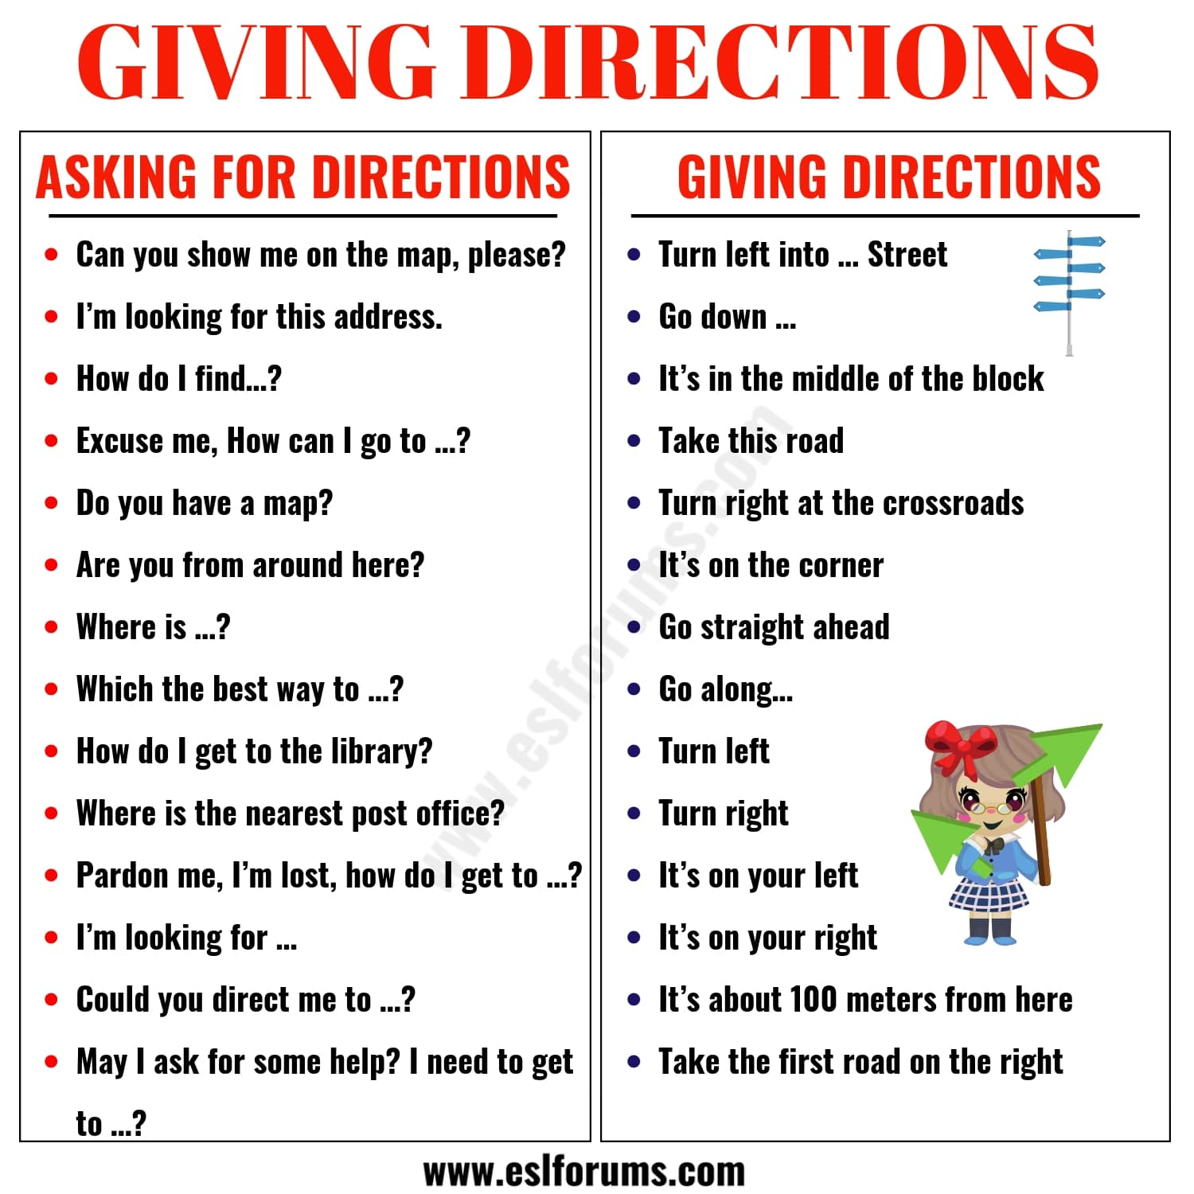

**2. Translate into Russian.**

Диалог 1

—Excuse me, where is the theatre situated?

—Go left here and then take the second right. The theatre will be around the corner.

Диалог 2

—Excuse me, could you tell me how to get to the nearest bank?

—Go straight on for about 2 miles. You will see the bank directly opposite to the post office.

Диалог 3

—Excuse me, can you tell me the way to the museum?

—It's rather far from here. Turn left and then right, go along for a mile or so and the museum is on your left.

Диалог 4

—Excuse me; I am looking for a cafe. Do you know how to get there?

—Go left here and turn right after you go past the bank. The cafe is in front of the market.

**3. Make a rout on the map.**

-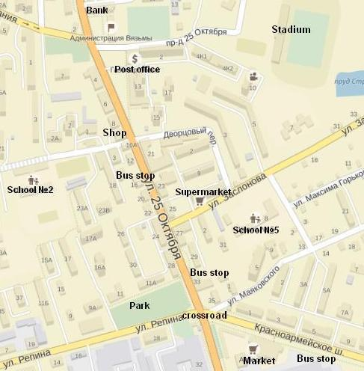Can you help me?

-Yes, of course. Where are you?

-I am opposite to the bus stop.

-What bus stop do you mean?

-I can see the park and opposite to me there is a bus stop.

-Okay. I got it.

-How can I get to the…..? Can you show me the way to….?

-Okay. Look. You should turn to the left and go straight ahead along 25th of October St. until you can see one more bus stop, please go past it. Then you need take the first turning to the left and go along Zagorodnij Lane. So there you can see the school in front of you.

- Thank you.

**4. Describe the rout from home up to your college.**

______________________________________________________________________________________________________________________________________________________________________________________________________________________________________________________________________________________________________________________________________________________________________________________________________________________________________________________________________________________________________________________________________________________________________________

**5. Complete the sentences.**

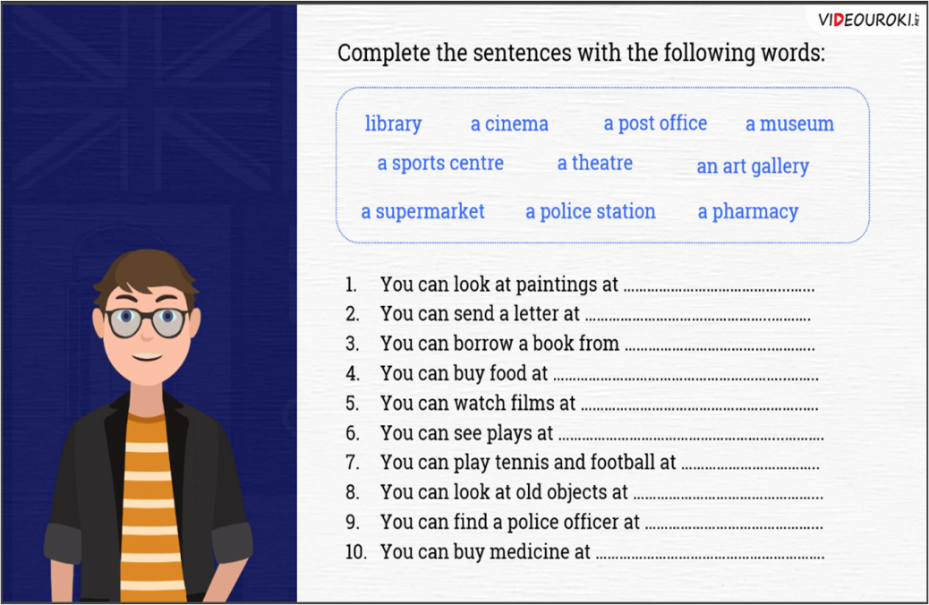

**6. Home task. Look at the picture and make the statements as true or false.**

<https://lingvoelf.ru/lessons/english/images/image7_16.jpg>

Начало формы

**The church is near the museum.**

 

Конец формы

Начало формы

**The hotel is near the restaurant.**

 

Конец формы

Начало формы

**The shops are near the mosque.**

 

Конец формы

Начало формы

**The park is near the hotel.**

 

Конец формы

Начало формы

**The main square is near the railway station.**

 

Конец формы