**Преподаватель:** Ишимова Н.В.

**Предмет:** Английский язык

**Обратная связь:** ishimova80@bk.ru

**Группа:** № 4-ГЭМ-22

**Дата:** 02.12.2024 г.

**Тема занятия:** «Safety. Modal verbs. Безопасность на рабочем месте. Модальные глаголы».  
**Основные источники:**1.Агабекян И.П. Английский язык для средних специальных заведений: учебник для сред. проф.образования. – Ростов-на-Дону, Феникс, 2010.

<https://college-balabanovo.ru/Student/Bibl/Pravo/AgabekEnglish.pdf>

**Дополнительные источники:**

1. Англо-русский и русско-английский словарь. Карантиров С.И., «Дом славянской книги», 2011.  
2. Интернет-ресурсы:  
<https://www.study.ru>; [www.learn-english.ru](https://ped-kopilka.ru/go/url=http:/www.learn-english.ru)  
**Инструкции (lesson instructions):**

**1. Point to these parts of your body. Say and learn.**

Ears, eyes, face, feet, fingers, hands, head.

**2. Look at the personal protection equipment (PPE)/ Complete the sentences below**

**Ear protectors Hard hat Face guard**

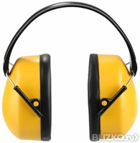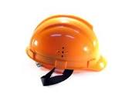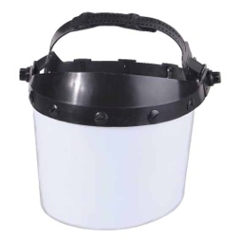

Boots Goggles Gloves

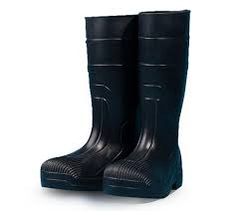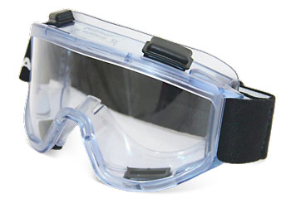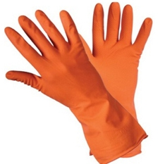

Safety harness respirator

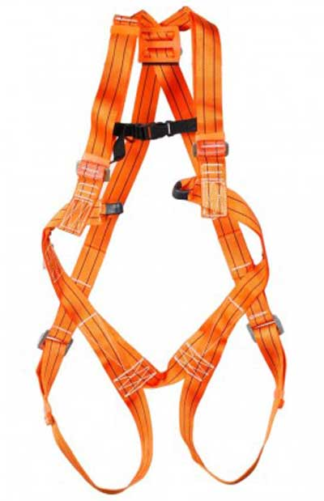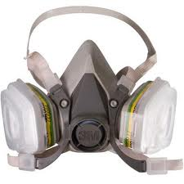

1. A hard hat protects your________

2 A face guard protects your__________

3 Boots protect your _______________

4__________protect your ears from noise

5__________ protect your hands

6__________protect your eyes

7. A _______ protects you from smoke and dangerous fumes

8. A _______ protects you from a fall

**3. Safety signs: colors and shapes.**

Safety signs are very important because the oil and gas industry has many hazards. Hazards are possible dangers like electricity, chemicals, hot things, gas, machines, noise, falling objects, and slippery surfaces. There are four main kinds of safety signs:

* Black and yellow triangles.

These signs warn us about hazards.

* Blue and white circles

These signs tell us “You must wear or do the thing in the picture”

* Red and white circles

These signs usually have a red band across them. They tell us we must not do things.

* Green and white squares or rectangles

These signs give information about safety.

**4. Match the signs with the descriptions given below.**

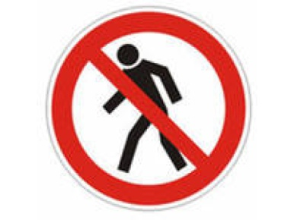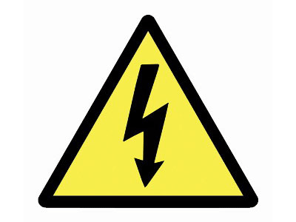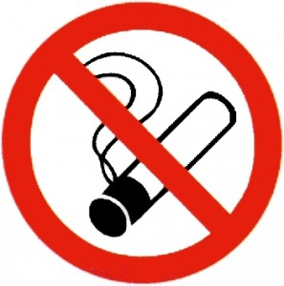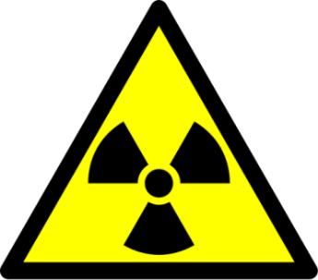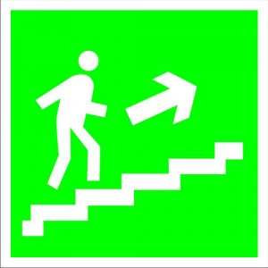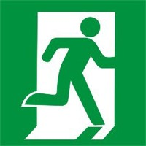

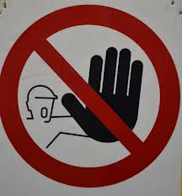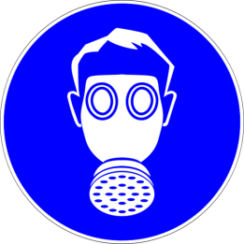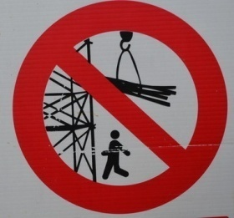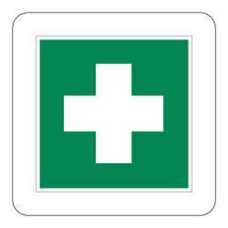

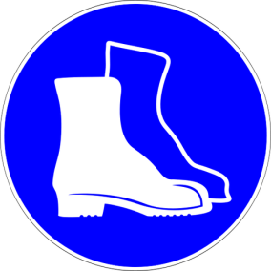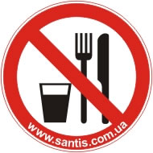

- Wear goggles!

- Don’t smoke here!

- This way to the emergency exit!

- Wear ear protectors!

- Don’t eat here!

- Danger! High voltage!

- Fire exit!

- Wear boots!

- Wear respirator!

- Do not enter!

- Danger! Radiation!

- Danger! Overhead crane!

- This way to the pharmacy!

- Do not touch!

- Drinking water is here!

**5. The pictures are from a safety manual for drilling crews. Which person is**

1. wearing loose clothes?

2. standing under a load?

3. running up or down steps?

4. eating near chemicals?

5. handling chemicals without PPE?

6. walking below people working?

7. standing between a wall and a moving load?

8. using a broken tool?

9. climbing without a safety harness?

10. doing the right thing : lifting correctly and keeping his back straight?

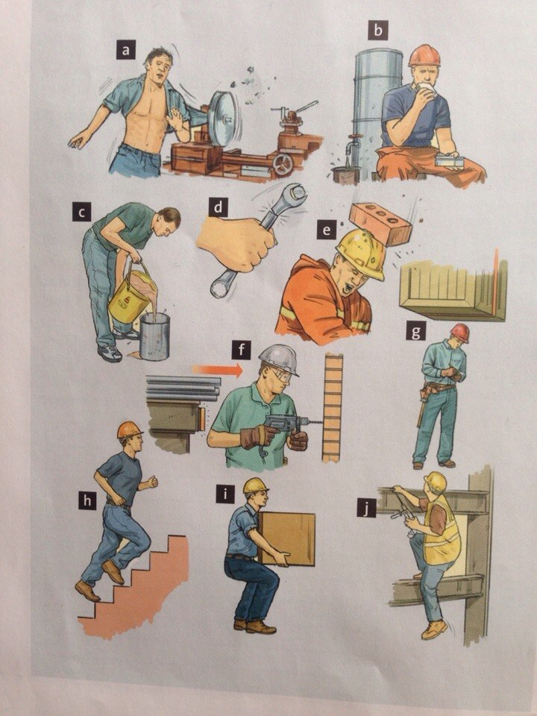

**6. Say what might happen in each situation?**

Example:

Machines might catch his loose clothes and injure him.

**7. Read the text.  
 Protective equipment and measures**

The employer should tell employees about any risks that require the wearing of protective equipment. The employer should provide protective equipment (such as protective clothing, headgear, footwear, eyewear, gloves) together with training on how to use it, where necessary. An employee is under a duty to take reasonable care for his/her own safety and to use any protective equipment supplied. The protective equipment should be provided free of charge to employees if it is intended for use at the workplace only. Usually, employees should be provided with their own personal equipment.

The Regulations cover various means of communicating health and safety information. These include the use of illuminated signs, hand and acoustic signals, e.g. fire alarms, spoken communication and the marking of pipe work containing dangerous substances. These are in addition to traditional signboards such as prohibition and warning signs. Fire safety signs, i.e. signs for fire exits and fire-fighting equipment are also covered.

They require employers to provide specific safety signs whenever there is a risk that has not been avoided or controlled by other means, e.g. engineering controls and safe systems of work. Where a safety sign would not help to reduce that risk, or where the risk is not significant, there is no need to provide a sign. The regulations, where necessary, require the use of road traffic signs within workplaces to regulate road traffic and also require employers to maintain the safety signs which are provided by them, explain unfamiliar signs to their employees and tell them what they need to do when they see a safety sign. The Regulations apply to all places and activities where people are employed, but exclude signs and labels used in connection with the supply of substances, products and equipment or the transport of dangerous goods.

**8. Study the grammar. Modal verbs. Watch the video tutorial by clicking on the link.**

<https://interneturok.ru/lesson/english/5-6-klassy/unit-4/modalnye-glagoly-ekvivalenty-modalnyh-glagolov>

**9. Translate the sentences into Russian.**

1) You can go, if you want to, of course, but could you leave the boy here if only for half an hour?

2) The boy said,” I feel sick”. Can I have some more orangeade?"

3) She can't come tomorrow because they are going out to visit Florence.

4) I simply could not refuse. They would have been hurt.

5) You can't talk about correspondence," the policeman said. "That's out?"

6) A little bit of boiled fish can't hurt you, you know.

7) He was not old; he couldn't have been more than forty.

8) But they can't be as bad as you!

9) "Oh," cried Fleur. "You can't have done it!"

10) Can she have been waiting for us all this time?

11) No, Jackie. Mother said you can't play with the knife.

12) Annie, as soon as we are gone, you can clear the table.

**10. Translate into English.**

1) Здесь нельзя переходить улицу.

2) Неужели уже так поздно?

3) Не мог он вам этого сказать.

4) Можете взять книгу с собой.

5) Он мог решать такие задачи, когда ему было восемь лет.

6) Карандашом писать нельзя.

7) Дайте мне, пожалуйста, ваш карандаш на минутку.

8) Покажите мне, пожалуйста, как пройти на Красную площадь.

9) Что же вы мне не сказали тогда?! Я бы мог вам купить эту книгу в Ленинграде.

10) Вы бы не могли еще немножко подождать?

11) Нельзя так говорить со старшими.

12) Можете закончить это дома.

13) Конечно, он мог бы тебе помочь тогда.