**Преподаватель:** Ишимова Н.В.

**Предмет:** Английский язык

**Обратная связь:** ishimova80@bk.ru

**Группа:** № 4-ГЭМ-22

**Дата:** 27.03.2025 г.

**Тема занятия:** «Инструменты для работы с металлом».  
**Основные источники:**1.Агабекян И.П. Английский язык для средних специальных заведений: учебник для сред. проф.образования. – Ростов-на-Дону, Феникс, 2010.

<https://college-balabanovo.ru/Student/Bibl/Pravo/AgabekEnglish.pdf>

**Дополнительные источники:**

1. Англо-русский и русско-английский словарь. Карантиров С.И., «Дом славянской книги», 2011.  
2. Интернет-ресурсы:  
<https://www.study.ru>; [www.learn-english.ru](https://ped-kopilka.ru/go/url=http:/www.learn-english.ru)  
**Инструкции (lesson instructions):**

**1. Rewrite new words and expressions.**

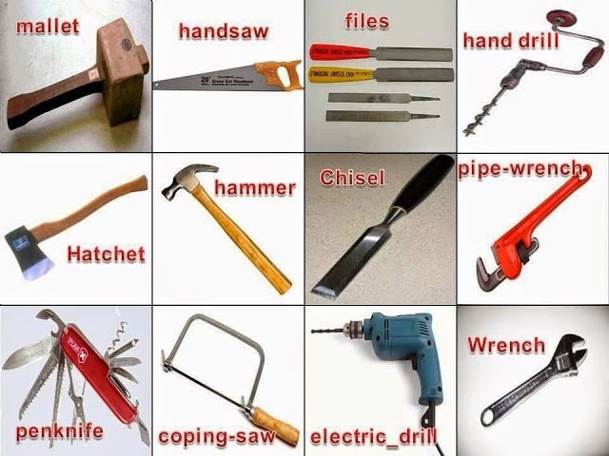

**2. Прочитайте следующие слова, пользуясь знаками транскрипции, и найдите их русские эквиваленты:**

atom indicator

turbine oxide

process automobile

corrosion disk

instrument

electromagnet

vanadium

molybdenum

**3. Read the text.**

**METALS**

Metals are materials most widely used in industry because of their properties. The study of the production and properties of metals is known as metallurgy.

The separation between the atoms in metals is small, so most metals are dense. The atoms are arranged regularly and can slide over each other. That is why metals are malleable (can be deformed and bent without fracture) and ductile (can be drawn into wire). Metals vary greatly in their properties. For example, lead is soft and can be bent by hand, while iron can only be worked by hammering at red heat.

The regular arrangement of atoms in metals gives them a crystalline structure. Irregular crystals are called grains. The properties of the metals depend on the size, shape, orientation, and composition of these grains. In general, a metal with small grains will be harder and stronger than one with coarse grains.

Heat treatment controls the nature of the grains and their size in the metal. Small amounts of other metals (less than l per cent) are often added to a pure metal. This is called alloying (легирование) and it changes the grain structure and properties of metals.

All metals can be formed by drawing, rolling, hammering and extrusion, but some require hot-working. Metals are subject to metal fatigue and to creep (the slow increase in length under stress) causing deformation and failure. Both effects are taken into account by engineers when designing, for example, airplanes, gas-turbines, and pressure vessels for high-temperature chemical processes. Metals can be worked using machine-tools.

The ways of working a metal depend on its properties. Many metals can be melted and cast in molds, but special conditions are required for metals that react with air.

**4. Answer the questions:**

1.​ What are metals and what do we call metallurgy?

2.​ Why are most metals dense?

3.​ Why are metals malleable?

4.​ What is malleability?

5.​ What are grains?

6.​ What is alloying?

7.​ What is crystalline structure?

8.​ What do the properties of metals depend on?

9.​ What changes the size of grains in metals?

10.​ What are the main processes of metal forming?

11.​ How are metals worked?

**5. Translate into English.**

1. Металлы - плотные материалы потому, что между атомами в металлах малое расстояние.

2. Металлы имеют кристаллическую структуру из-за правильного расположения атомов.

3. Чем меньше зерна, тем тверже металл.

4. Легирование изменяет структуру зерен и свойства металлов.

5. Металл деформируется и разрушается из-за усталости и ползучести.

**6. Домашнее задание: составить кроссворд по теме урока.**