Преподаватель: Ишимова Н.В.
Предмет: Английский язык
Обратная связь: e-mail: ishimova80@bk.ru
Группа: № 3-ОР-23(к)
Урок: № 5-6
Дата: 08.09.2023 г.
Тема занятия: «Семейные взаимоотношения. Family Ties». «The Present Simple Tense».
Основные источники:
1.Безкоровайная Г. Т., Койранская Е. А., Соколова Н. И., Лаврик Г. В. Planet of English: учебник английского языка для учреждений СПО. — М., 2014.
https://s.11klasov.ru/12889-planet-of-english-uchebnik-anglijskogo-jazyka-bezkorovajnaja-gt-i-dr.html
Дополнительные источники:
1. Англо-русский и русско-английский словарь. Карантиров С.И., «Дом славянской книги», 2011.
2. Интернет-ресурсы:
https://www.study.ru; www.learn-english.ru
Выполнение заданий:
M. No, I haven’t. Have you?
K. I’ve met her several times.
M. If she’s like her brother she must be good-looking. Bob is handsome,
isn’t he? What does she look like?
K. …
1. Learn the vocabulary.
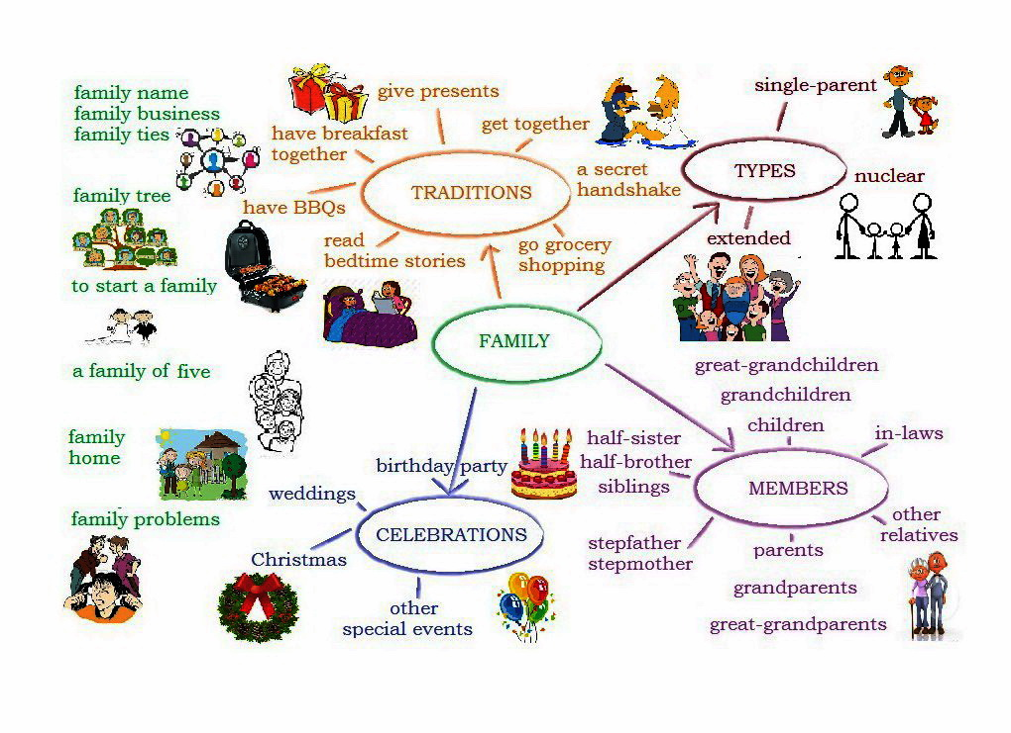
2. To learn more about British families I offer you to read the text and fill in the gaps (1-6) with phrases (A-G). There is one phrase that you do not need to use.
“The Changing face of the British Family”
The traditional nuclear family of 1960s Britain consisted of a married male breadwinner and female care living in a household with their children. This is now a thing of the past.
Since the sixties, a dramatic change in the structure of family life has taken place in the UK. Marriage rates have been declining 1)... . Divorce rates have increased dramatically in the past four decades. There are also more and more couples 2)… .
Single parents are no longer the exception and women have started giving birth to fewer children later on in life. The result is that it is becoming increasingly rare to find the nuclear family structure in 21st century Britain. Indeed, researchers agree that by 2020 it will be very difficult to talk about the “typical British family”3)… .
While many people worry about the “breakdown” of the family, others propose another way of looking at things. These people suggest that families are not falling apart. Rather, the future of the family is stronger than ever in the UK. Families may live apart 4)… . Surveys show that family members who live apart still turn to each other 5)… . And families are still responsible for most of the socializing which occurs in British life. Also, it is conversations between family members 6)… .
In other words, the change that the family has undergone in the last few decades is not so much breakdown. It is a reinvention. Families in the UK are still highly valued and will continue to be so in the future.
A) but the emotional support and commitment between family members remains just as strong as ever.
B) because there will be many different types
C) so in fact relationships between family members are improving
D) for support when important life events occur
E) which accounts for a large percentage of telephone usage in the UK
F) and the age at which people marry has been increasing
G) who have chosen not to marry
3. Match the proverbs with their explanations and give the Russian equivalents.
1. It runs in the family
2. Your own flesh and blood
3. Blood is thicker than water.
a) a member of your family, no matter what
b) an ability or talent that is passed on through the generation.
c) family ties are stronger than any others, despite arguments.
4. Study the grammar. The Present Simple Tense. Watch the video tutorial by clicking on the link.
https://interneturok.ru/lesson/english/2-klass/grammatika-3/nastoyaschee-prostoe-vremya-the-present-simple-tense
5. Do training exercises 1, 2.
6. Home task. Answer the question «What is family value»? Use the scheme below.
