Преподаватель: Ишимова Н.В.
Предмет: Английский язык
Обратная связь: ishimova80@bk.ru
Группа: № 4-ГЭМ-21
Дата: 15.02.2024 г.
Тема занятия: «Инструменты рабочего. Их составные части; функции. Tools and equipment».

Основные источники:
1. Абрамова Р.Н., Болсуновская Л.М., Баранова А.В. Геология рудных месторождений и разведка полезных ископаемых. Часть 1. Горное дело. Профессиональный английский язык.
Дополнительные источники:
1.Англо-русский и русско-английский словарь. Карантиров С.И., «Дом славянской книги», 2011.
2. Интернет-ресурсы:
https://www.study.ru; www.learn-english.ru
Выполнение заданий (lesson instructions):
1. Learn the vocabulary. Rewrite new words and expressions into your copy books with translation.

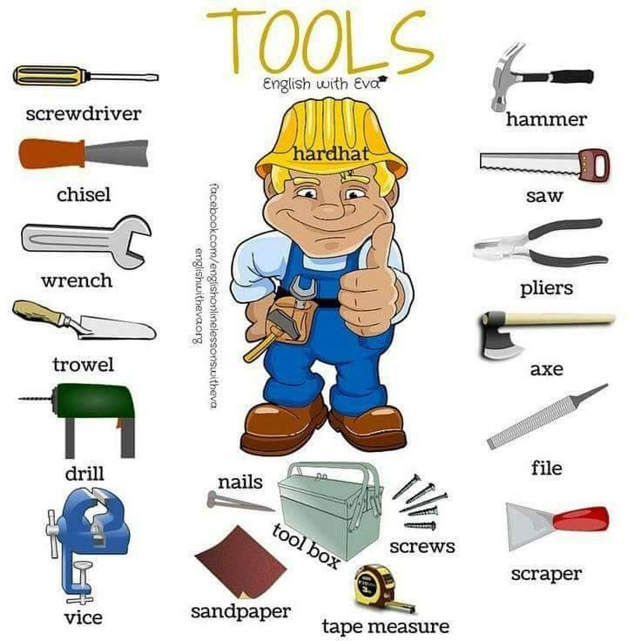

2. Read and translate the text.

Mining Equipment
List of mining equipment: Mining is the extraction of valuable minerals or other geological materials from the land of a deposit.
For this extraction to be done efficiently, we need machinery specialized in mining. This mining equipment has reinforced chassis and more powerful engines so that they can transport all the material.
Some mining machines are used to transport mining or workers (miners), you can also use machinery to introduce explosives with a longitudinal arm making the explosion more effective.
Other types of mining machinery are used to introduce the concrete into the wall of the rock making it more consistent and safer.
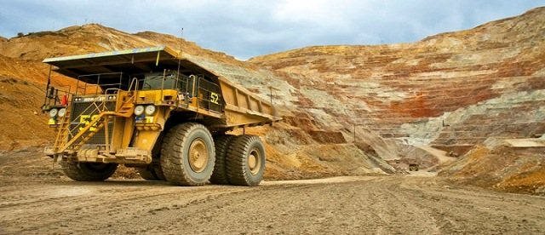
Working in the mining industry can be a dangerous place if you don’t know what you’re doing. Regular training is essential and understanding the machines you’re working near or operating plays an important role in all aspects of the industry.
Each type of mining equipment comes with its own set of mining activities. The most common types of mining equipment vary depending whether the work is being carried out above or below ground or mining for gold, metals, coal or crude oil. From drilling machines to excavators, crushing and grinding equipment – the mining industry comes complete with all the right tools. New to the job and want to find out what it all means? Here’s a few of the industry’s most common types of equipment and why they’re important for the job.
Mining Drills
Probably one of the most common pieces of mining equipment, drills are an important part of the underground mining operation. Underground mining is carried out when rocks or minerals are located at a fair distance beneath the ground. But then they need to be brought to the surface. Underground specialized mining equipment such as trucks, loaders, diggers etc. are used to excavate the material and are normally hauled to the surface with skips or lifts for further processing. Drilling is normally required to place explosive charges to liberate the minerals from the overburden material. Underground mining techniques have progressed significantly over the past years, including using remote controlled machinery.
Drills assist in creating holes descending underground. If miners are required to work underground, drills can also be used in ensuring the holes are large enough to serve as a portal for miners to enter. Directional drilling is also a type of mining technology where miners will use the tools and certain methods to drill wells.
Blasting Tools
Blasting tools are an essential part of the mining industry and are used to break down and fracture materials (usually rocks) by use of a calculated amount of explosive to liberate the sought-after product from the waste material. Blasting is also used to remove pockets of unwanted material that are preventing mining machines and personnel to get to the seam containing the materials of interest. Unmanned drill rigs will drill holes at pre-determined depths and positions on a blast face to ensure that a particular size fraction is achieved and that little of the overburden is liberated with the blasting to reduce material handling costs. Once this process has been completed, an excavator is used to recover the blasted rocks and other debris that has been dislodged during the blasting. The material is then conveyed to a central conveying system which will take it directly to the surface or via a skip and hoist system.
Blasting equipment is used for both underground and open pit mining operations and is known to be one of the most hazardous aspects of the job.
For mining operations to be successful good blast designs are absolutely vital as poor practices and excessive explosives can result in damage to rock structures causing unwanted caving.
Earth Movers
For above ground mining, earth movers are utilized regularly to carry loose soil and earth from one location to another. Earth movers play an important role in the mining industry because the equipment is specifically designed to work on large earth-moving and mining projects for a faster and more practical process. Used for digging, pushing and transporting the earth, they require the specialized skills of an operator.
Earth movers are heavy mining equipment that the industry would struggle to survive without and work hand in hand with bulldozers. Earth movers are normally used for removing overburden or waste material, which enables the excavators to remove the material or mineral of interest. Bulldozers are used to move this overburden material around to create a working surface for other equipment such as haul trucks and excavators.
Crushing Equipment
As its name suggests, crushing equipment is used to crush rock and stone. Designed to achieve maximum productivity and high reduction rate, mining crushing equipment can come in a variety of different types for a range of jobs.
Crushing equipment is specially configured to break down the hard rock matter or gravel to a manageable size for transportation or conveying. They are valuable pieces of equipment in the industry because they reduce the costs associated with handling of larger sized material and also ensure efficient liberation of elements of interest in downstream processing of the material. In an opencast or strip mining operation, the run of mine (ROM) material is normally transported to the primary crusher by haul trucks, and in underground mining operations it is conveyed to the primary crusher. Crushing equipment is important to the mining process because it reduces the use of precious excavated resources and eliminates the amount of material on site.
3. Home task. Retell the text.

